**This – That \ These – Those**

*Look and say:* ***this, that, these, those****.*

1. ________ are Alima’s rings. C:\Users\Елена\Desktop\i (1).jpg 
2. ________ is Masid’s bed. C:\Users\Елена\Desktop\i (1).jpg 
3. ________ is Masid’s grandfather Halim. C:\Users\Елена\Desktop\i (1).jpg 
4. ________ is a watermelon. C:\Users\Елена\Desktop\i (1).jpg 
5. ________ is a pineapple cake. C:\Users\Елена\Desktop\i (1).jpg 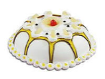
6. ________ is a knife. C:\Users\Елена\Desktop\i (1).jpg 
7. ________ are spoons and forks C:\Users\Елена\Desktop\i (1).jpg 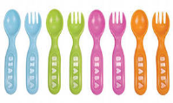
8. ________ is a slice of chocolate cake. C:\Users\Елена\Desktop\i (1).jpg 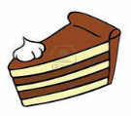
9. ________ are two cartons of milk. C:\Users\Елена\Desktop\i (1).jpg 
10. ________ is Eddy’s schoolbag. C:\Users\Елена\Desktop\i (1).jpg 