Present Simple vs Present Continuous (TEST) Name:
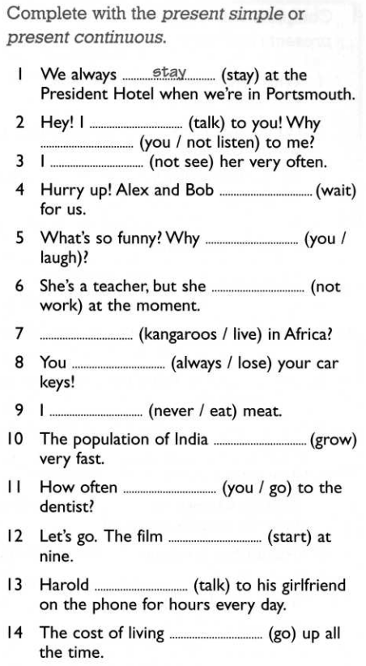 | Write the case of use.  1. repeated action / habit  2. __________________________________________________  3. __________________________________________________  4. __________________________________________________  5. ___________________________________________________  6. __________________________________________________  7. ___________________________________________________  8. __________________________________________________  9. __________________________________________________  10. __________________________________________________  11. __________________________________________________  12. __________________________________________________  13. __________________________________________________  14. __________________________________________________

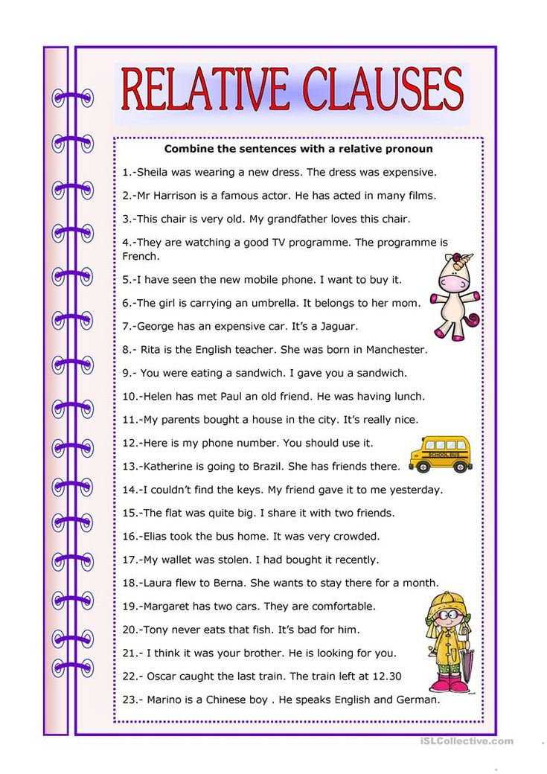
EXAMS WINTER 2023 (Click on 3)
Phonetics
- “A proud parent” Ship or Sheep p.178
- “Noisy neighbours” Ship or Sheep p.170-171
Vocabulary (Unit 1)
see the WORD LIST
Grammar (просмотреть и выучить формулы, примеры, когда используем каждое правило!)
- Present Simple (SB p.138-139 + grammar copybook + WB p.66 spelling & pronunciation)
- Present Continuous (SB p.138-139 + grammar copybook + WB p.67 spelling)
- Adverbs of frequency (WB p.66 + grammar copybook)
- Stative verbs (WB p.67)
- Relative pronouns (WB p.68)
Texts & Dialogues
- “About Jobs” (text based on dialogues from SB p.7)
- “It’s a Dog’s Life” (SB p.12)
Phrasal verbs (SB Ex.33 p.13)
Word formation (SB Ex.32 p.13)
Prepositional phrases (WB Ex.15,16 p.71)
Communicative dialogues (SB Ex.34 p.14; WB Ex.20 p.8)
! ЭКЗАМЕН СОСТОИТСЯ ПОСЛЕ ЯНВАРСКИХ КАНИКУЛ !
Точная дата будет известна 9-10 января.

