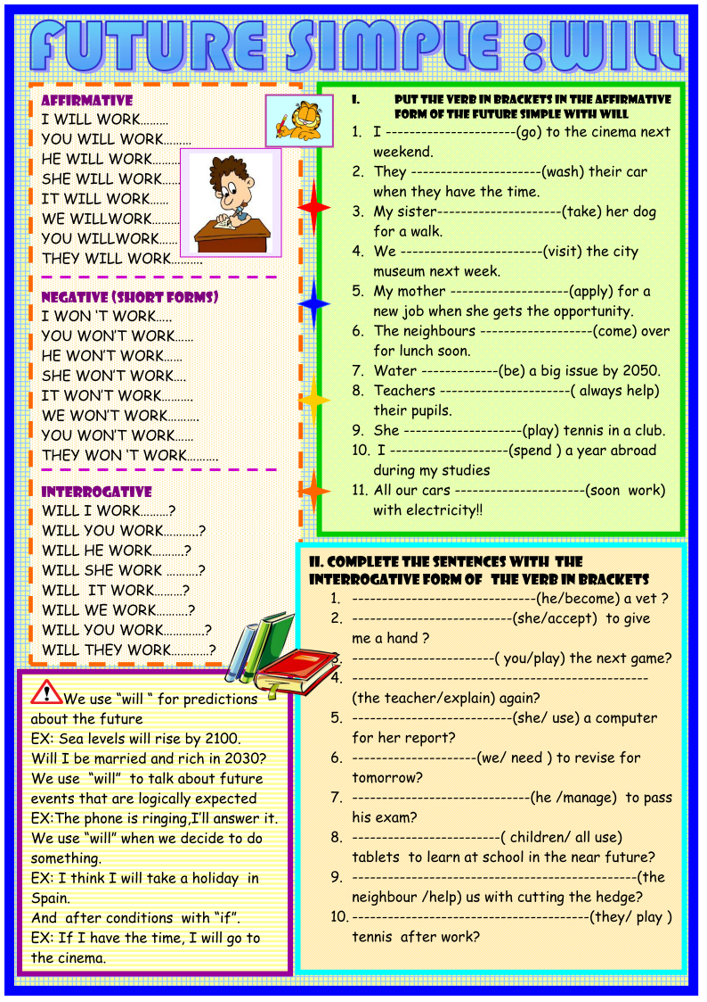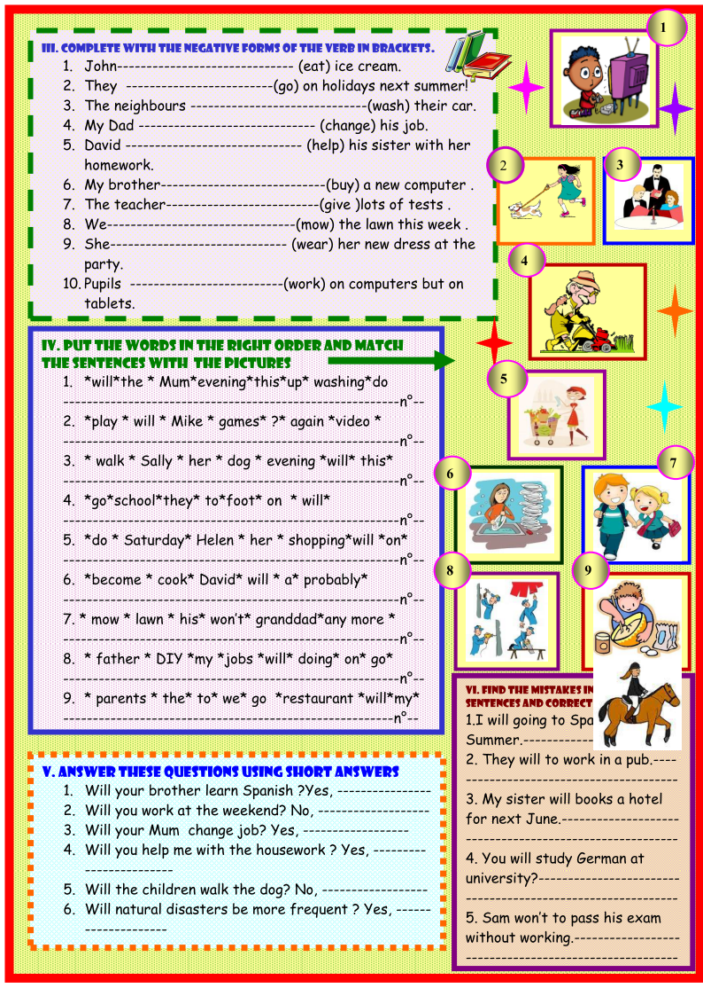
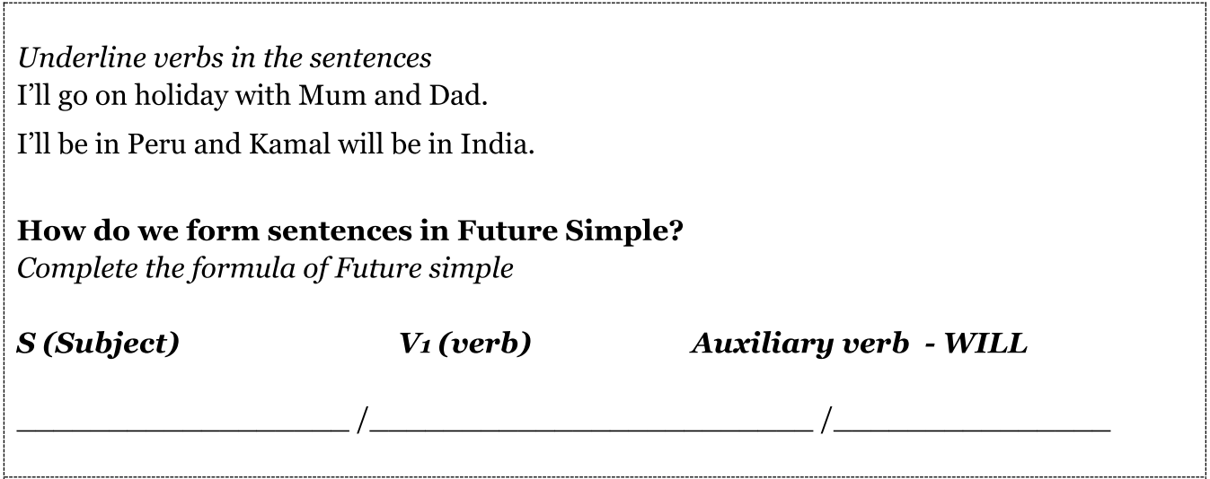
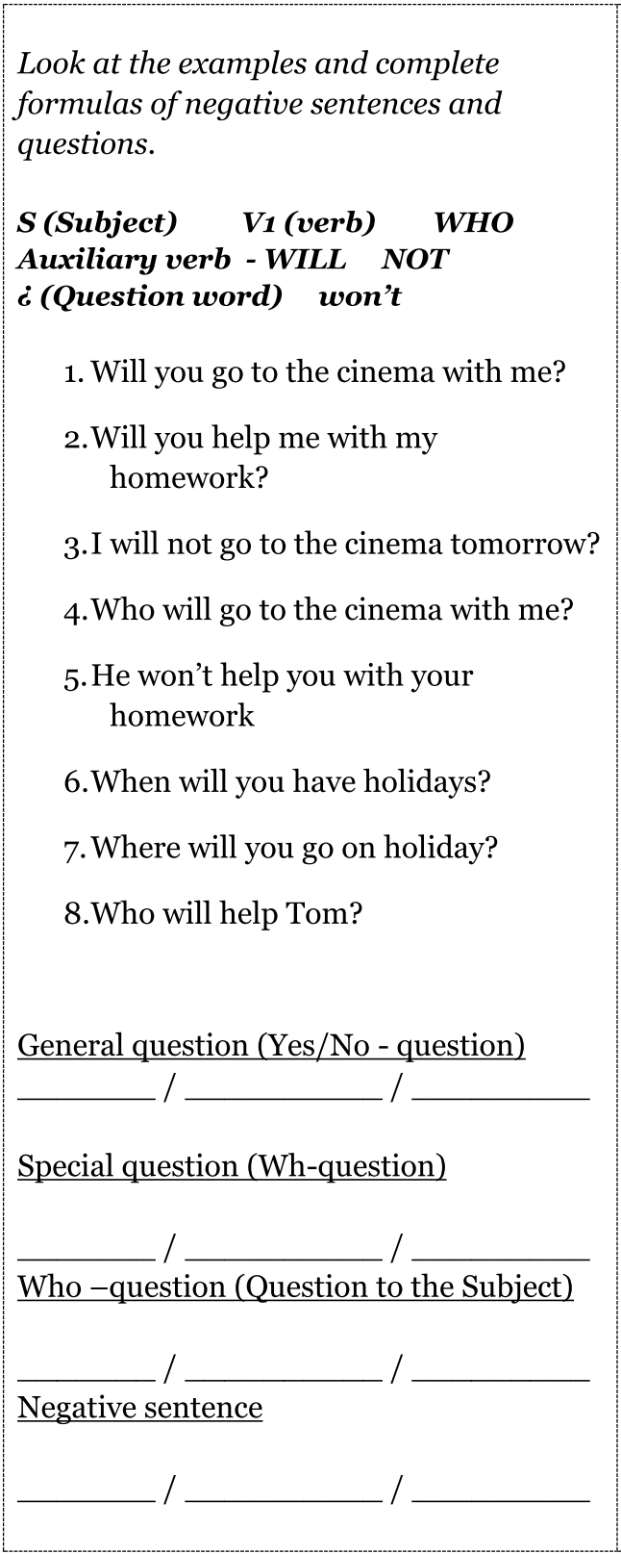
Will you help me with my homework? | Request  (просьба)
I’ll phone you every day when I’m on holiday. | Promise  (обещание)
I’m hungry!  I’ll make you a sandwich | On-the-spot decisions  (спонтанные решения)
I think, you will have a great time there! | Opinion about future  (мнение о будущем)
In 2099 people will go to the moon on holiday | Prediction  (предсказание)
If you don’t put on a scarf, you’ll catch a cold. | Warning  (предупреждение)
Give me your money, or I’ll shoot! | Threat  (угроза)

