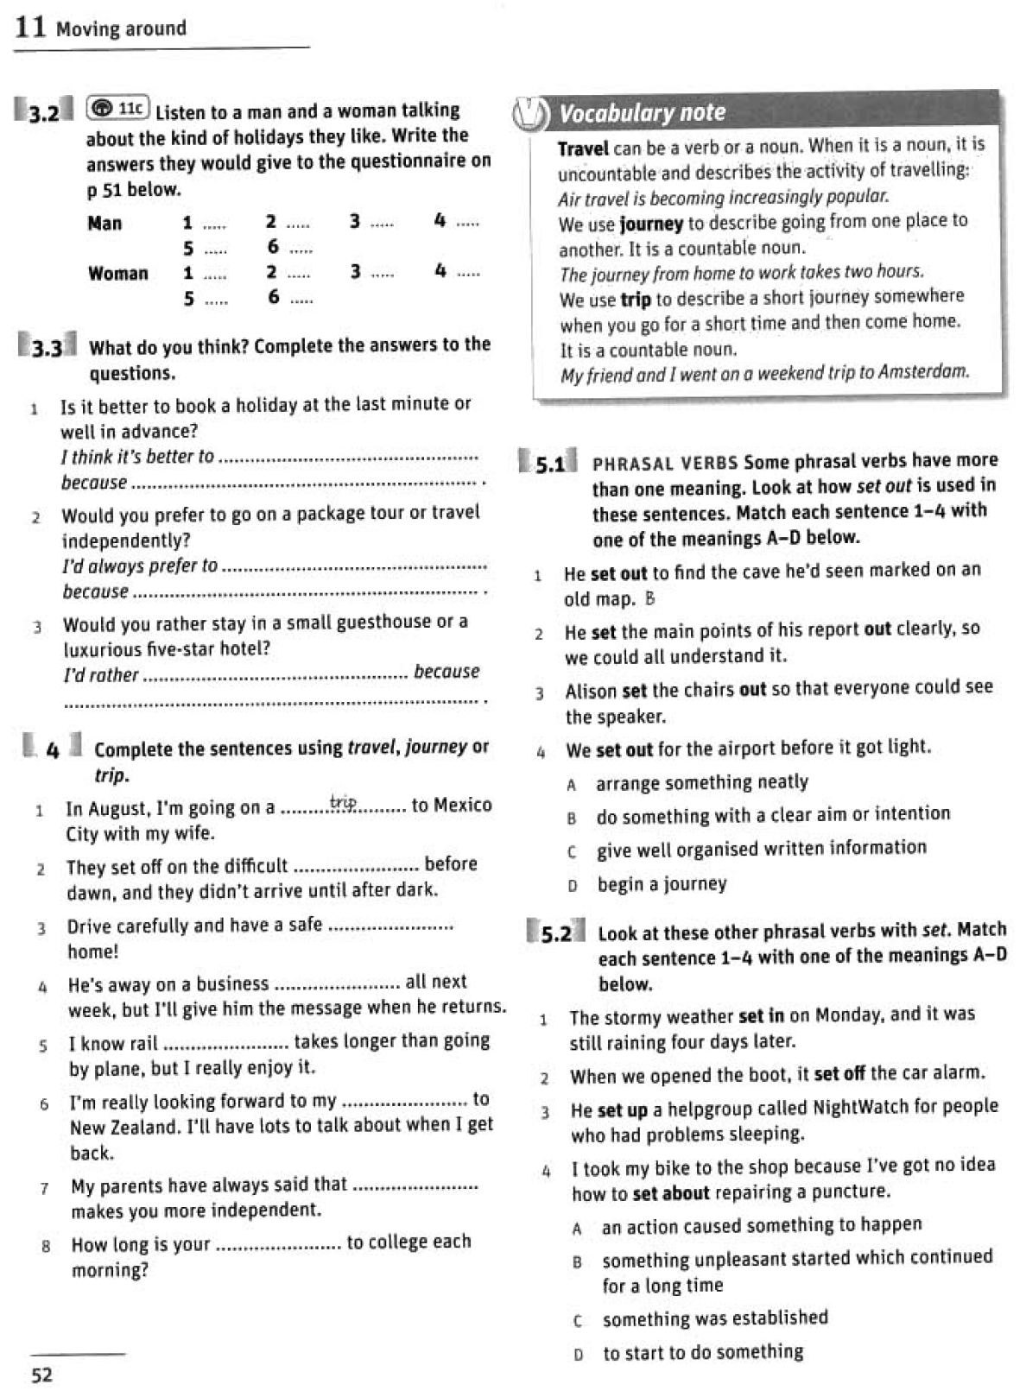

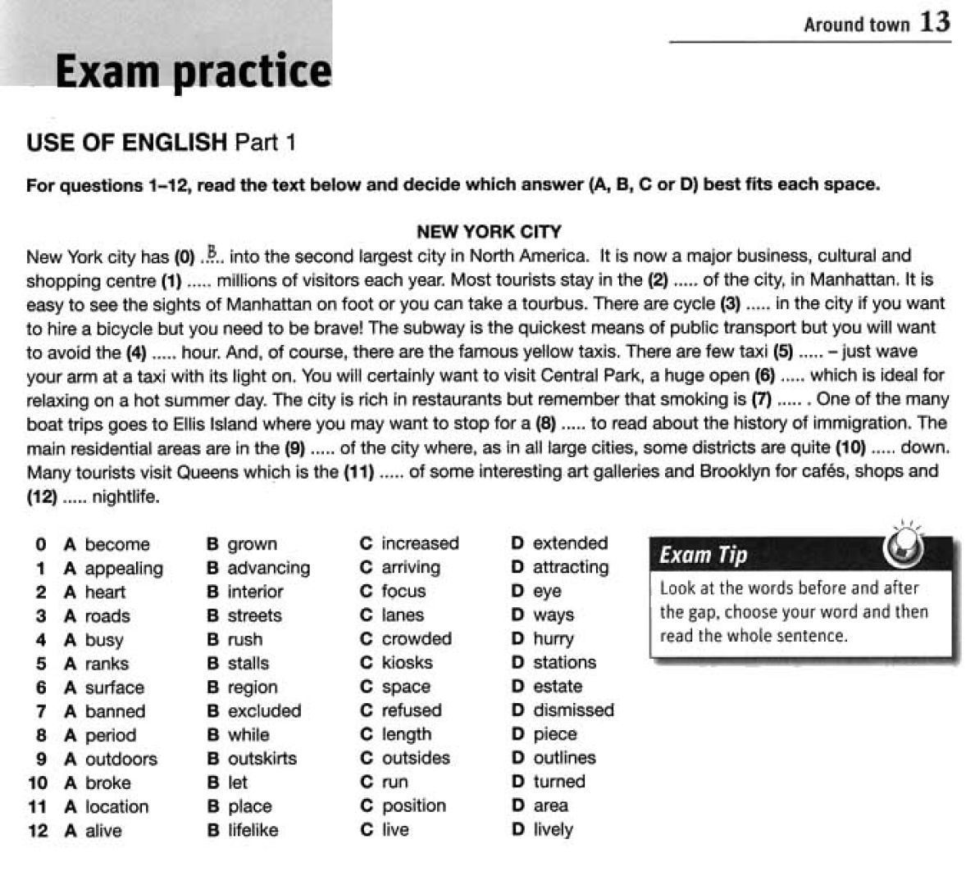

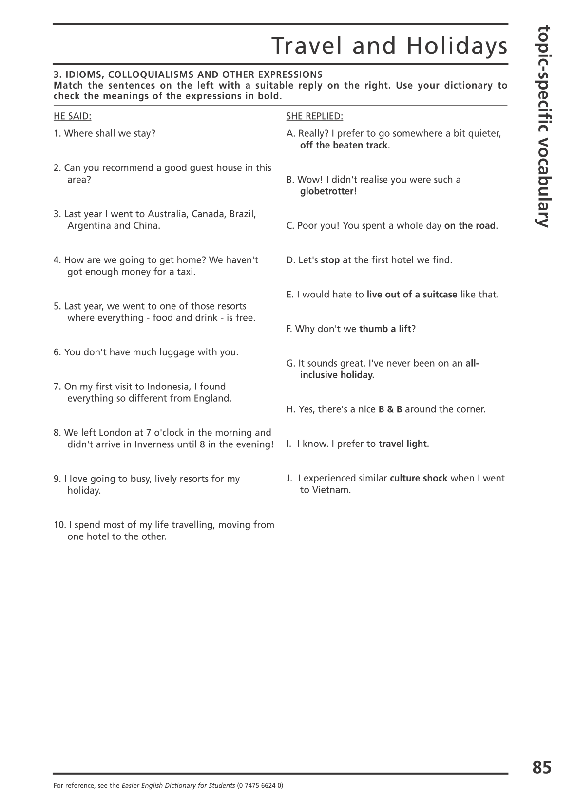
Imagine that you are doing a project “Life in the countryside” together with your friend. You have found some illustrations and want to share the news. Leave a voice message to your friend. In 2.5 minutes be ready to tell the friend about the photos:
- explain the choice of illustrations for the project by briefly describing them and noting the differences;
- mention the advantages (1-2) of living in such places;
- mention the disadvantages (1-2) of living in such places;
- express your opinion on the subject of the project – which place of living is best for you and why.
You will speak for not more than 3 minutes (2-3 sentences for every item of the plan, 12-15 sentences total). You have to talk continuously.

