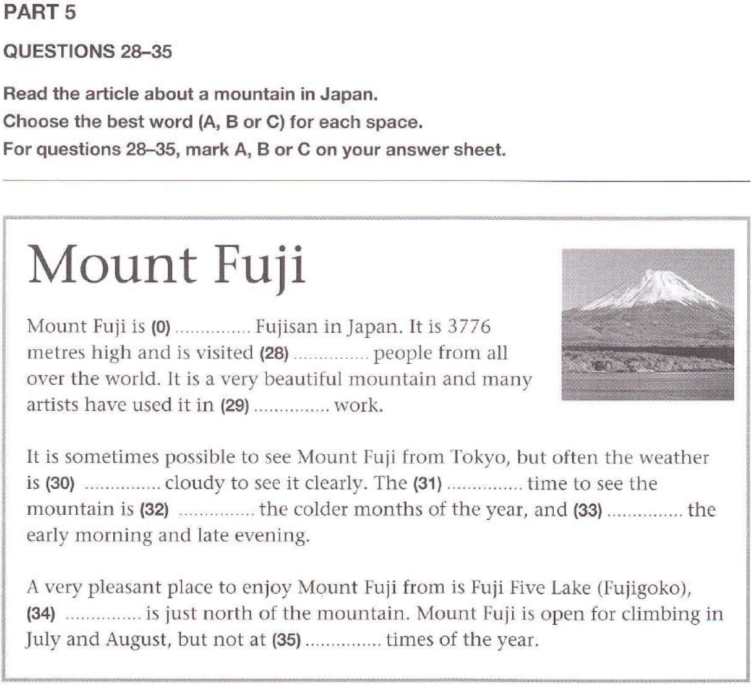
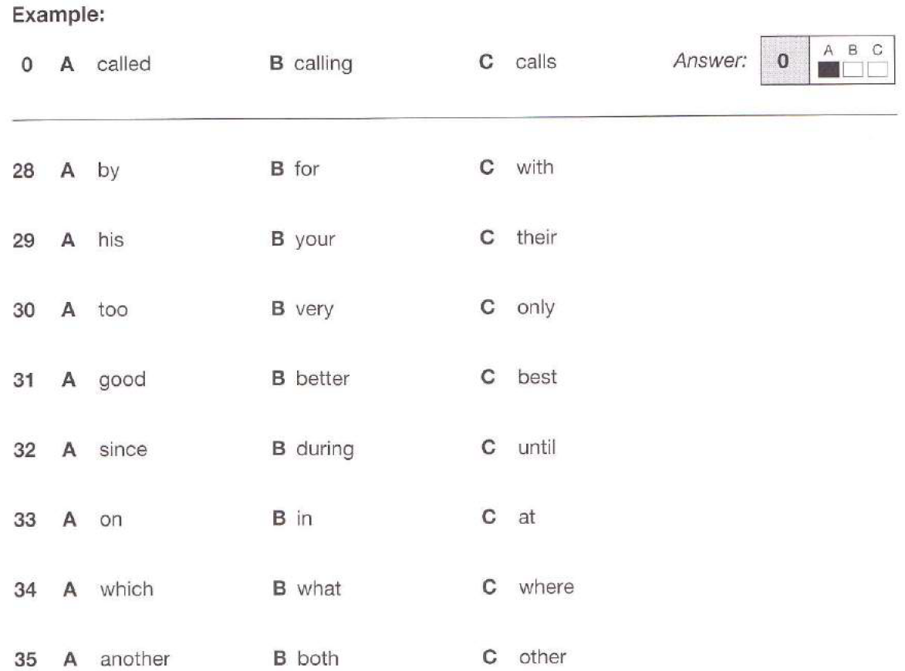

Study the examples and complete the rule  - We must protect our planet.  - We mustn’t pollute rivers.  - Must we protect our planet?  Do we use any auxiliary verbs to make negative sentences or questions with must? yes / no  Complete the formulas:  + S + ______ + V₁  - S + ______ + ______  ? (___)______ + ______ + _____? | 