To be going to
собираться что-то сделать
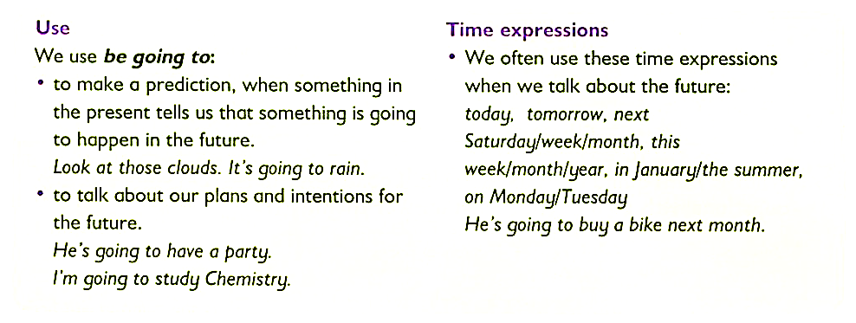
+ Subject + to be + going to + Verb ___________________________________________
- S + to be + not + going to + V ____________________________________________
? (QW) + To be + S + going to + V ____________________________________________
Who + to be (is) + going to + V ____________________________________________
Short answers:
Yes, I am. No, I'm not. Yes, he is. No, he isn't. Yes, you are. No, you aren't.

