‘At the Butcher’s Shop’,  the phonetic dialogue | ‘It’s cheaper to eat at Marguerite’s’,  the phonetic dialogue
‘At the Butcher’s Shop’,  the phonetic dialogue | ‘It’s cheaper to eat at Marguerite’s’,  the phonetic dialogue
‘At the Butcher’s Shop’,  the phonetic dialogue | ‘It’s cheaper to eat at Marguerite’s’,  the phonetic dialogue
‘At the Butcher’s Shop’,  the phonetic dialogue | ‘It’s cheaper to eat at Marguerite’s’,  the phonetic dialogue
‘At the Butcher’s Shop’,  the phonetic dialogue | ‘It’s cheaper to eat at Marguerite’s’,  the phonetic dialogue

SB p. 55, Dialogues A, B, C + SB p. 66 Dialogues A
SB p. 55 Dialogue A  (‘I’m going to get some things from the corner shop, Bill’)  +  SB p. 55 Dialogue B  (‘Can I take your order?’) | SB p. 55 Dialogue C  (‘Good evening, sir. May I take your order?’)  +  SB p. 55 Dialogue B  (‘Can I take your order?’)
SB p. 55 Dialogue A  (‘I’m going to get some things from the corner shop, Bill’)  +  SB p. 55 Dialogue B  (‘Can I take your order?’) | SB p. 55 Dialogue C  (‘Good evening, sir. May I take your order?’)  +  SB p. 55 Dialogue B  (‘Can I take your order?’)
SB p. 55 Dialogue A  (‘I’m going to get some things from the corner shop, Bill’)  +  SB p. 55 Dialogue B  (‘Can I take your order?’) | SB p. 55 Dialogue C  (‘Good evening, sir. May I take your order?’)  +  SB p. 55 Dialogue B  (‘Can I take your order?’)
SB p. 66 Dialogue A  (‘What about going to Sweden for our holiday this year?’) | SB p. 66 Dialogue A  (‘What about going to Sweden for our holiday this year?’)

SB p. 59 ‘Food, Fun and Celebration around the World’ (text)

Speak about the celebration of  Chinese New Year. | Speak about the celebration of  American Independence Day.
Speak about the celebration of  Chinese New Year. | Speak about the celebration of  American Independence Day.
Speak about the celebration of  Chinese New Year. | Speak about the celebration of  American Independence Day.
Speak about the celebration of  Chinese New Year. | Speak about the celebration of  American Independence Day.
Speak about the celebration of  Chinese New Year. | Speak about the celebration of  American Independence Day.

Speaking
Speak about your favourite festival.  In your speech you should:  - tell us the name of the festival;  - tell us when and where it takes place;  - tell us why people celebrate it;  - tell us what happens during the festival;  - recommend the festival. | Speak about bad service.  In your speech you should:  - tell us the name of the place you complain about;  - tell us all your complaints;  - tell us which way the service can be improved.
Speak about the recipe of your favourite dish.  In your speech you should:  - tell us the name of the dish;  - tell us the ingredients for your favourite dish;  - tell us how to cook your favourite dish;  - recommend your favourite dish. | Speak about the recipe of your favourite dish.  In your speech you should:  - tell us the name of the dish;  - tell us the ingredients for your favourite dish;  - tell us how to cook your favourite dish;  - recommend your favourite dish.
Speak about your favourite festival.  In your speech you should:  - tell us the name of the festival;  - tell us when and where it takes place;  - tell us why people celebrate it;  - tell us what happens during the festival;  - recommend the festival. | Speak about the recipe of your favourite dish.  In your speech you should:  - tell us the name of the dish;  - tell us the ingredients for your favourite dish;  - tell us how to cook your favourite dish;  - recommend your favourite dish.
Speak about your favourite festival.  In your speech you should:  - tell us the name of the festival;  - tell us when and where it takes place;  - tell us why people celebrate it;  - tell us what happens during the festival;  - recommend the festival. | Speak about bad service.  In your speech you should:  - tell us the name of the place you complain about;  - tell us all your complaints;  - tell us which way the service can be improved.
Speak about bad service.  In your speech you should:  - tell us the name of the place you complain about;  - tell us all your complaints;  - tell us which way the service can be improved. | Speak about your favourite festival.  In your speech you should:  - tell us the name of the festival;  - tell us when and where it takes place;  - tell us why people celebrate it;  - tell us what happens during the festival;  - recommend the festival.

Grammar (theory) WB p. 92 – 93
Speak about plural nouns, give examples.  - What is the difference between countable / uncountable nouns?  - How do we form plurals of countable nouns?  - What are the irregular plural forms? | Speak about countable / uncountable nouns, give examples.  - What is the difference between countable / uncountable nouns?  - How do we form plurals of countable nouns?  - What are the irregular plural forms?  - How can we show quantity of uncountable nouns?
Speak about plural nouns, give examples.  - What is the difference between countable / uncountable nouns?  - How do we form plurals of countable nouns?  - What are the irregular plural forms? | Speak about quantifiers used with nouns, give examples.  - some – any / a – an;  - a lot of / much – many / how much – how many / (a) few – (a) little;  - containers, measurements.
Speak about plural nouns, give examples.  - What is the difference between countable / uncountable nouns?  - How do we form plurals of countable nouns?  - What are the irregular plural forms? | Speak about quantifiers used with nouns, give examples.  - some – any / a – an;  - a lot of / much – many / how much – how many / (a) few – (a) little;  - containers, measurements.
Speak about countable / uncountable nouns, give examples.  - What is the difference between countable / uncountable nouns?  - How do we form plurals of countable nouns?  - What are the irregular plural forms?  - How can we show quantity of uncountable nouns? | Speak about quantifiers used with nouns, give examples.  - some – any / a – an;  - a lot of / much – many / how much – how many / (a) few – (a) little;  - containers, measurements.
Speak about countable / uncountable nouns, give examples.  - What is the difference between countable / uncountable nouns?  - How do we form plurals of countable nouns?  - What are the irregular plural forms?  - How can we show quantity of uncountable nouns? | Speak about plural nouns, give examples.  - What is the difference between countable / uncountable nouns?  - How do we form plurals of countable nouns?  - What are the irregular plural forms?

Grammar (practice) EM p. 86
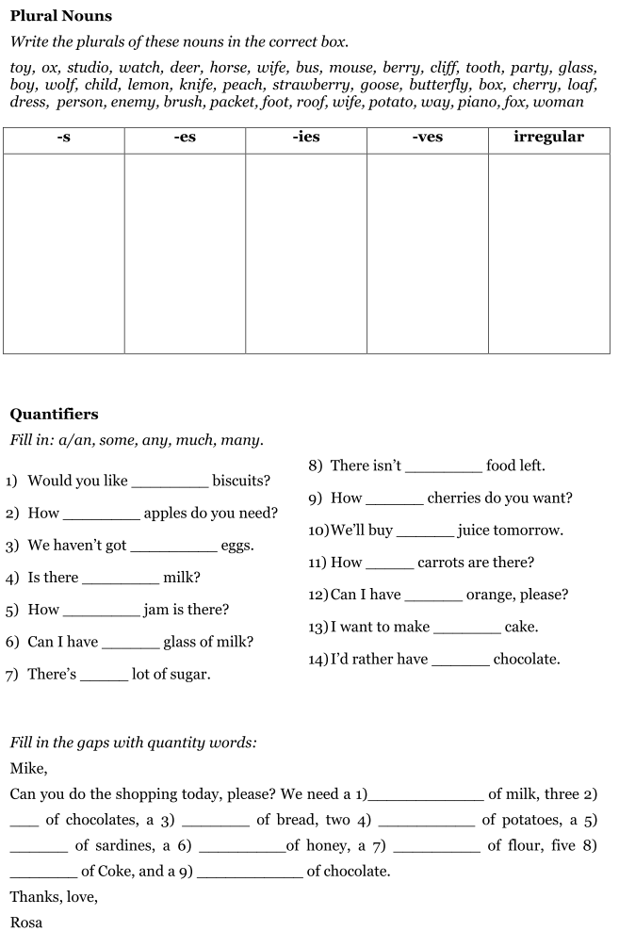
Vocabulary SB p. 54, p. 55, p. 56, p. 59, p. 66, p. 67 (EM p. 100 – p. 109)
Vocabulary Test A
Translate the following words into English:
- булочка
- буханка
- уксус
- резать ломтиками
- сковорода
- стеклянная банка
- встречать праздник
- традиционная еда
- удивительный
- виноград
- для начала
- бобовые
- брокколи
- чечевица
- оставаться (о еде)
- основное блюдо
- жир
- острый
- имбирь
- кастрюля
- картонная коробка
- жестяная банка
- приносить удачу
- бездомный кот
- багет

Read the definitions of some words and write the words. The first letter is already there.
- A vegetable with large green leaves that you eat in a salad l_ _ _ _ _ _
- A round deep metal container used for cooking s_ _ _ _ _ _ _
- The biggest part of a meal m_ _ _ c_ _ _ _ _
- A breakfast food that you eat with milk c_ _ _ _ _ _ _ _ _
- A flat metal container used for cooking food in oil f_ _ _ _ _ p_ _
- A public celebration with a lot of people and music p_ _ _ _ _
- A glass container with a lid used for jam or honey j_ _

Choose the correct preposition:
- I'm going to get some things in/from the corner shop.
- I'll have the vegetable soup to start up/with.
- People dance around/through the streets.
- There's plenty of chicken left after/from last night.
- What would you like on/for the main course?
- I go to my uncle's house to/for a traditional meal.
- We went to a huge firework display at/in our local park.

Fill in the missing words:

- We need a _________ of bread and some cheese.
- What's today's _________?
- Millions of people around the world __________ Chinese New Year.
- During the festival we ________ the new year.
- I'm afraid I felt sorry for that ________ cat again.
- People wear dragon and lion __________.

Vocabulary Test B
Translate the following words into English:
- салат-латук
- персик
- специи
- гарнир
- блюдо дня
- белок
- маринованные огурцы
- нож
- глубокая тарелка
- барбекю
- богатство
- независимость
- груша
- зелёный лук
- кислый
- ингредиенты
- наливать
- бутылка
- пакет
- кунжут
- клубника
- местный магазинчик
- умирать от голода
- солёный
- резать кубиками

Read the definitions of some words and write the words. The first letter is already there.
- Bread, pasta, pulses contain a lot of c_ _ _ _ _ _ _ _ _ _ _
- A metal container for sardines t_ _
- An animal without a home s_ _ _ _
- A type of bread that is small and round with a hole in the middle b_ _ _ _
- Extremely hungry s_ _ _ _ _ _ _
- A type of pasta s_ _ _ _ _ _ _ _
- We use this word to speak about bread l_ _ _

Choose the correct preposition:
- There was a lot of chicken left after/over.
- Would you like anything for/to drink?
- Sesame seed balls bring us luck in/for the year ahead.
- I can't wait for/to the next Fourth of July.
- Can you change this spicy soup about/for me, please?
- I'm afraid I felt sorry about/for that stray cat.
- On the Fourth of July we celebrate being independent of/from Britain.

Fill in the missing words:

- I think that traditional __________ like this one are great.
- I gave the cat all our chicken because it was ____________.
- Sesame seed balls bring ________ for the year ahead.
- May I take your __________?
- On the Fourth of July American people celebrate being _______ from Britain.
- But Les, what about your __________ ?

Vocabulary Test C
Translate the following words into English:
- царство
- ослик
- орёл
- павлин
- шимпанзе
- оса
- верблюд
- млекопитающее
- рептилия
- насекомое
- хищник
- травоядное
- животные, находящиеся на грани вымирания
- дикое животное
- домашнее животное
- домашний скот
- турагент
- переполненный
- позволить себе
- в действительности
- замёрзнуть до смерти
- О боже!
- уксус
- витамины
- углеводы

Read the definitions of some words and write the words. The first letter is already there.
- A vegetable with large green leaves that you eat in a salad l_ _ _ _ _ _
- A round deep metal container used for cooking s_ _ _ _ _ _ _
- The biggest part of a meal m_ _ _ c_ _ _ _ _
- A breakfast food that you eat with milk c_ _ _ _ _ _ _ _ _
- A flat metal container used for cooking food in oil f_ _ _ _ _ p_ _
- A public celebration with a lot of people and music p_ _ _ _ _
- A glass container with a lid used for jam or honey j_ _

Choose the correct preposition:
- I'm going to get some things in/from the corner shop.
- I'll have the vegetable soup to start up/with.
- People dance around/through the streets.
- There's plenty of chicken left after/from last night.
- What would you like on/for the main course?
- I go to my uncle's house to/for a traditional meal.
- We went to a huge firework display at/in our local park.

Fill in the missing words:

- We need a _________ of bread and some cheese.
- What's today's _________?
- Millions of people around the world __________ Chinese New Year.
- During the festival we ________ the new year.
- I'm afraid I felt sorry for that ________ cat again.
- People wear dragon and lion __________.

