PRESENT SIMPLE (spelling & pronunciation)

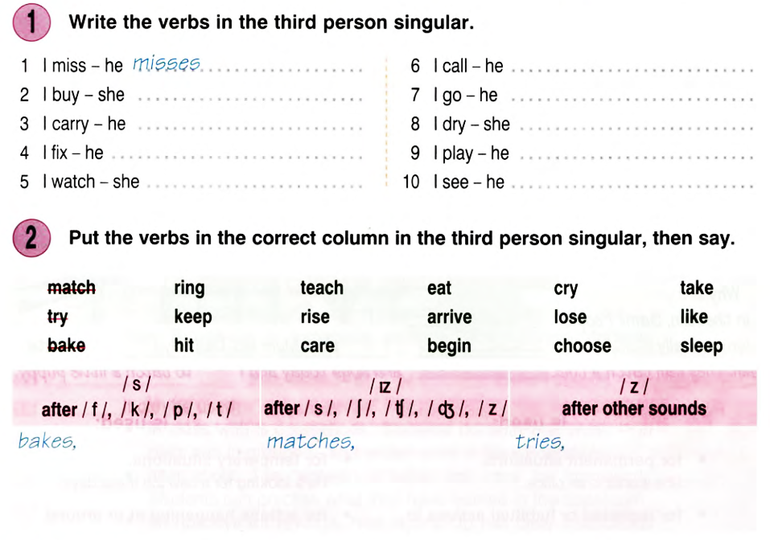
PRESENT CONTINUOUS (spelling)

