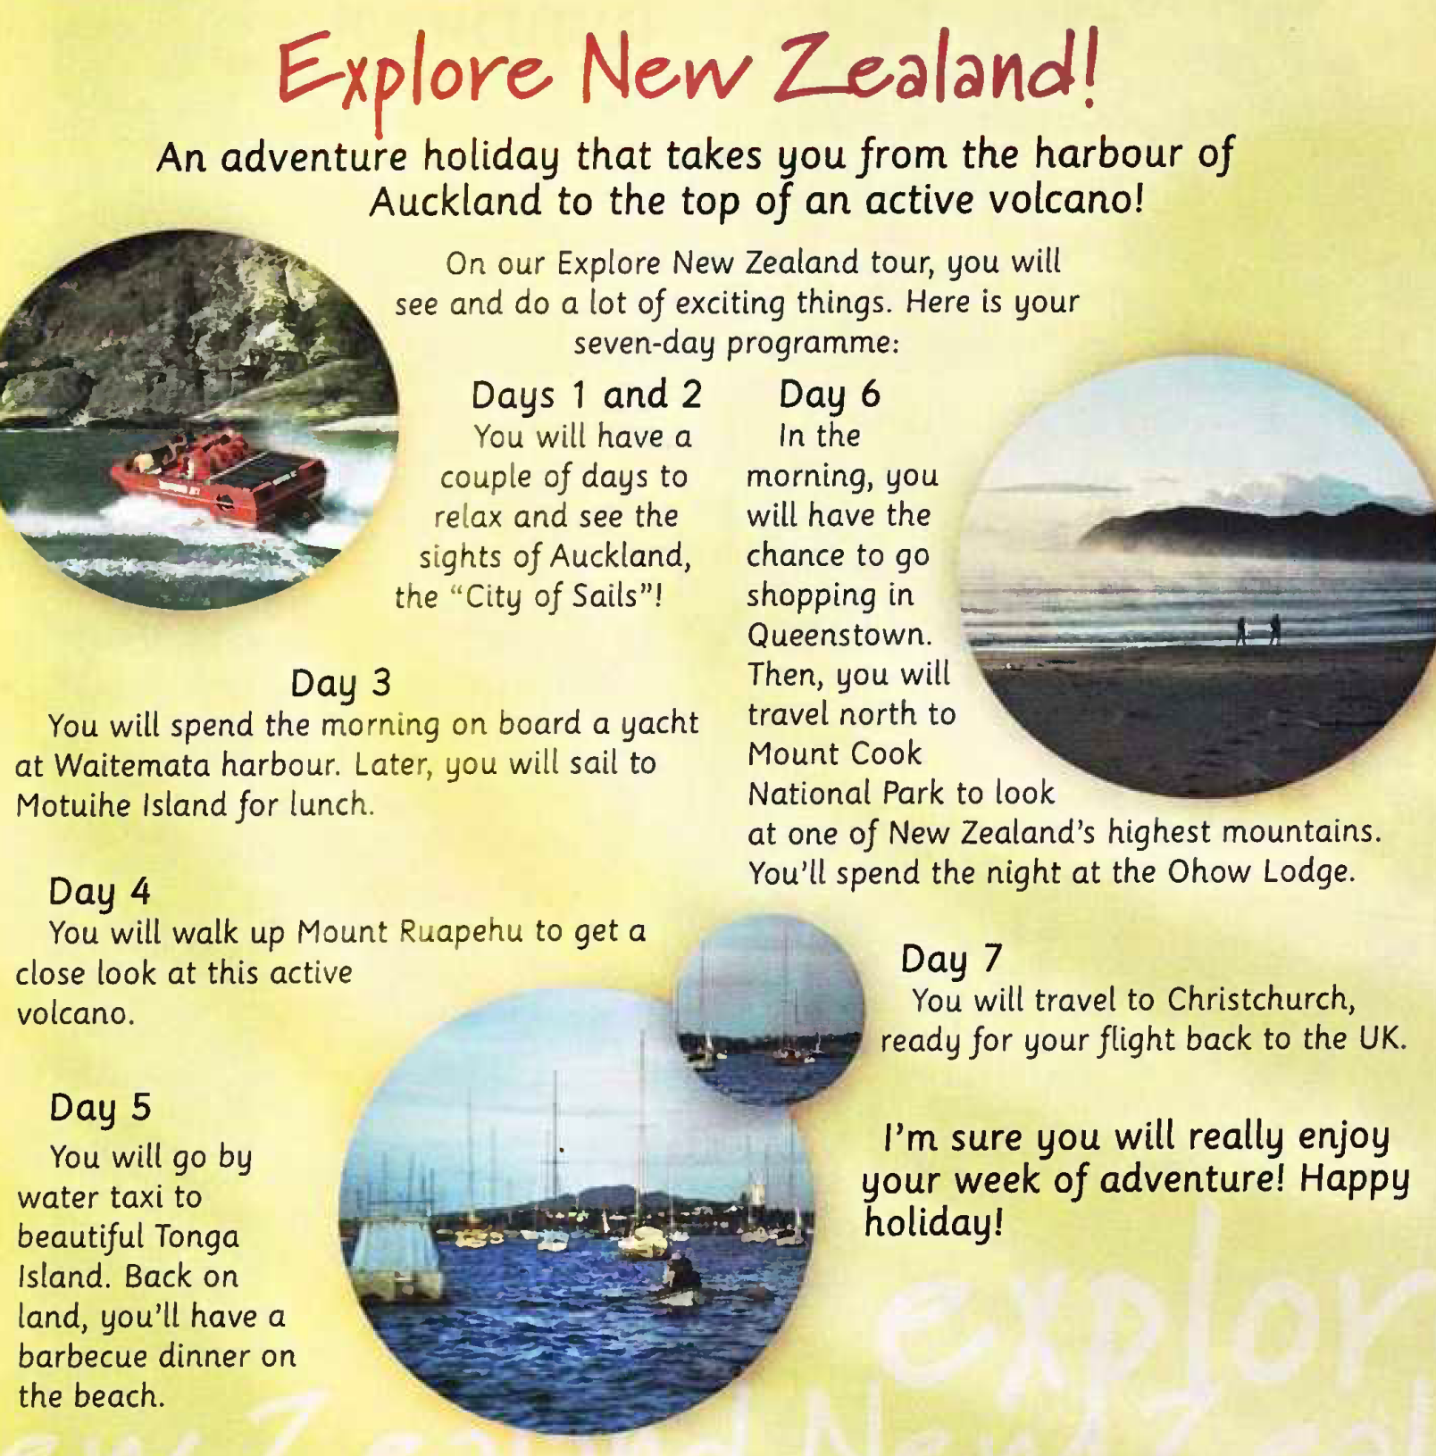
Auckland - city
Waitemata
Motuihe
Ruapehu
Queenstown
Ohow Lodge
Christchurch

+ S + auxiliary verb WILL + V1 (verb)
General Q (yes/no Q)
Will + S + V1
Special Q (Wh-Q)
QW + will + S + V1
WHO Q (Q to the S)
Who + will + V1
- S + will + not (won't) + V1

Will you help me with my homework? | Request  (просьба)
I’ll phone you every day when I’m on holiday. | Promise  (обещание)
I’m hungry!  I’ll make you a sandwich | On-the-spot decisions  (спонтанные решения)
I think, you will have a great time there! | Opinion about future  (мнение о будущем)
In 2099 people will go to the moon on holiday | Prediction  (предсказание)
If you don’t put on a scarf, you’ll catch a cold. | Warning  (предупреждение)
Give me your money, or I’ll shoot! | Threat  (угроза)
