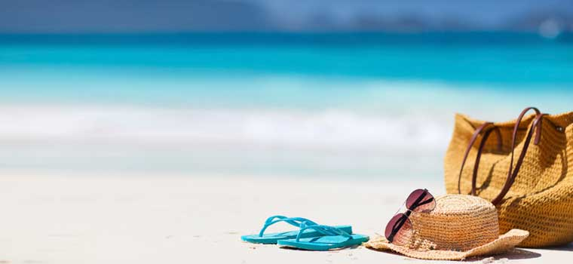**PAST SIMPLE OR PRESENT PERFECT?**

**Complete the sentences with the right verb tense:**

1. Anne and Catherine ______________ (travel) to France.
2. They _______________ (go) to The Netherlands last year.
3. My parents ______________ (work) in a factory two years ago but they ___________________ (manage) to get a new job this year.
4. We ________________ (visit) seven different countries so far.
5. She _________________ (cut) her finger. Now she’s bleeding.
6. Paul ________________ (drink) two pints of beer last night, so ________________ (arrive) late this morning. He ________________ (fall) asleep.
7. Sarah _______________ (be) married for seven years. She _______________ (get) married in 2009.
8. I _______________ (buy) a new book on Monday. I ______________ (already / finish) reading it.
9. Steve ____________ (just / book) a room in a hotel near the city centre.
10. Last year, my holidays _______________ (be) great. I _______________ (go) to Spain.
11. The phone _____________ (just / ring).
12. Sandra _______________ (take) a lot of pictures when she ___________ (visit) Ireland.
13. We _________________ (meet) many interesting people yesterday at the club.
14. Mary ________________ (not / see) Peter since 2010. She _________________ (already / write) him some letters but he _______________ (never / answer).
15. Pauline and Tom _________________ (send) a postcard to their family. They _________________ (have) a great time in Algarve.
16. We ___________________ (work) very hard to go to Brazil. We finally ___________________ (get) the money in April. We _________________ (go) to the Travel Agency and _________________ (book) a two-room flat in Rio de Janeiro.
17. The girls ______________ (go) to the cinema last weekend.
18. We _________________ (not / buy) the tickets for the show yet.
19. Tom _________________ (disappear) at the beach. Nobody knows where he is.

