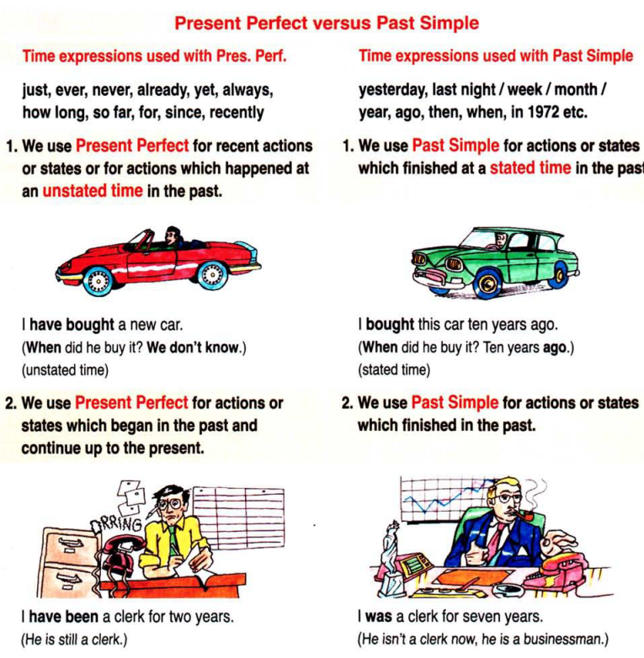
PRESENT PERFECT  + _____ + _____ + ____/____  ________________________________  - _____ + _____ + _____ + ____/____  ________________________________  ? (_____) + _____ + _____ + ____/____  ________________________________  Yes, _____ _____. No, _____ ______.  Yes, _____ _____. No, _____ ______.  Who + _____ + ____/____ | PAST SIMPLE  + _____ + ____/____  ________________________________  - _____ + _____ + _____ + _____  ________________________________  ? (_____) + _____ + _____ + _____  ________________________________  Yes, _____ _____. No, _____ ______.  Who + _____

