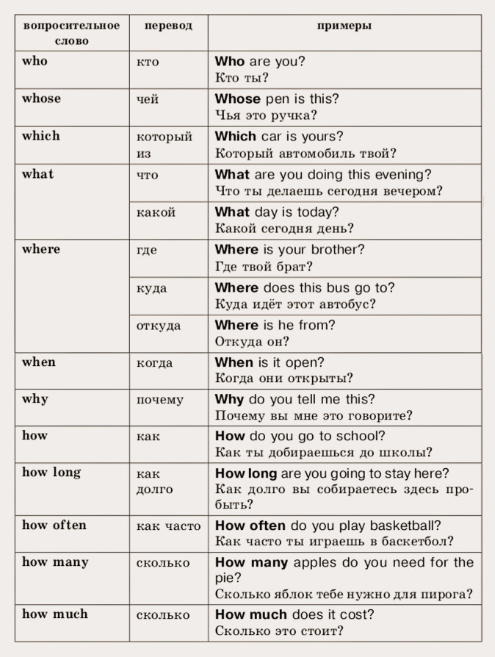

_ _ _ is Abdul making a cake?
Because it’s Grandma’s birthday.
_ _ _ _ is Grandma’s birthday?
It’s on the fifteenth of November.
_ _ _ _ _ _ is Grandma?
She’s ninety years old.
_ _ _ are you?
I’m fine, thanks.
_ _ _ _ _ is Grandma Alima?
She’s at the market.
_ _ _ is Sinbad?
He’s Masid’s uncle.
_ _ _ _ _ birthday is it?
It’s Grandma’s.
_ _ _ _ is Abdul making?
He’s making a cake.

