scare**s** people

like**s** Halloween

hate**s** fire

live**s** in a mansion

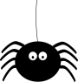

eat**s** spiders

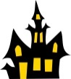

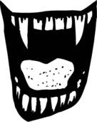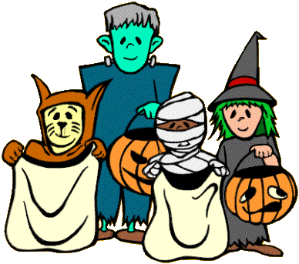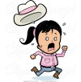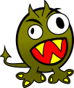

Frankenstein

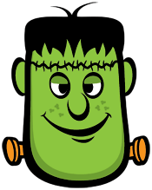

Dracula

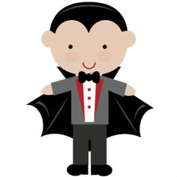

The Mummy

Frankenstein

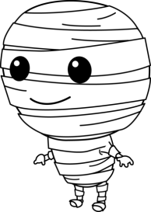

The Ghost



The Witch

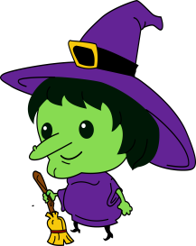

Make a monster!

This is _______________________________________________(name)

He/She is a _________________________________(Monster type!)

___________________________________________________(likes)

___________________________________________________(lives)

___________________________________________________(hates)

___________________________________________________(eats)